

School of Engineering

Department of Electrical and Computer Engineering

|  |  |  |
| --- | --- | --- |
| **ENG 142** | **Fundamental Engineering Design** | **Prof Jesson** |

**Lab # 1: Breadboard Basics and Measuring Electrical Quantities**

**Part I: Breadboard Basics**

A breadboard is a construction base for prototyping of electronics. The term is commonly used to refer to solderless breadboard. Because the solderless breadboard does not require soldering, it is reusable. This makes it easy to use for creating temporary prototypes and experimenting with circuit design. A variety of electronic systems may be prototyped by using breadboards, from small analog and digital circuits to complete central processing units (CPUs) [1].

Figure 1 shows a typical small breadboard which is suitable for building simple circuits. Breadboards have many tiny sockets (called 'holes') arranged on a 0.1" grid. The leads of most components can be pushed straight into the holes. ICs are inserted across the central gap with their notch or dot to the left. Wire links can be made with single-core plastic-coated wire of 0.6mm diameter (the standard size). Stranded wire is not suitable because it will crumple when pushed into a hole and it may damage the board if strands break off.

The top and bottom rows are linked horizontally all the way across as shown by the red and black lines on the diagram. The power supply is connected to these rows, + at the top and 0V (zero volts) at the bottom [2].

The purpose of this lab is to familiarize ourselves with electronic lab equipment and more specifically the measurement of current, voltage and resistance in order to gain a better understanding of the relationships between them.

Procedure (see below)



Figure 1. Typical Breadboard with Socket Interconnections.

Follow the following steps to create a breadboard from the schematic shown below, Figure 2:



**Figure 2. Circuit Diagram.**

**Step 1:**

Build the circuit as shown if Figure 3 and apply the test probes across the resistor:

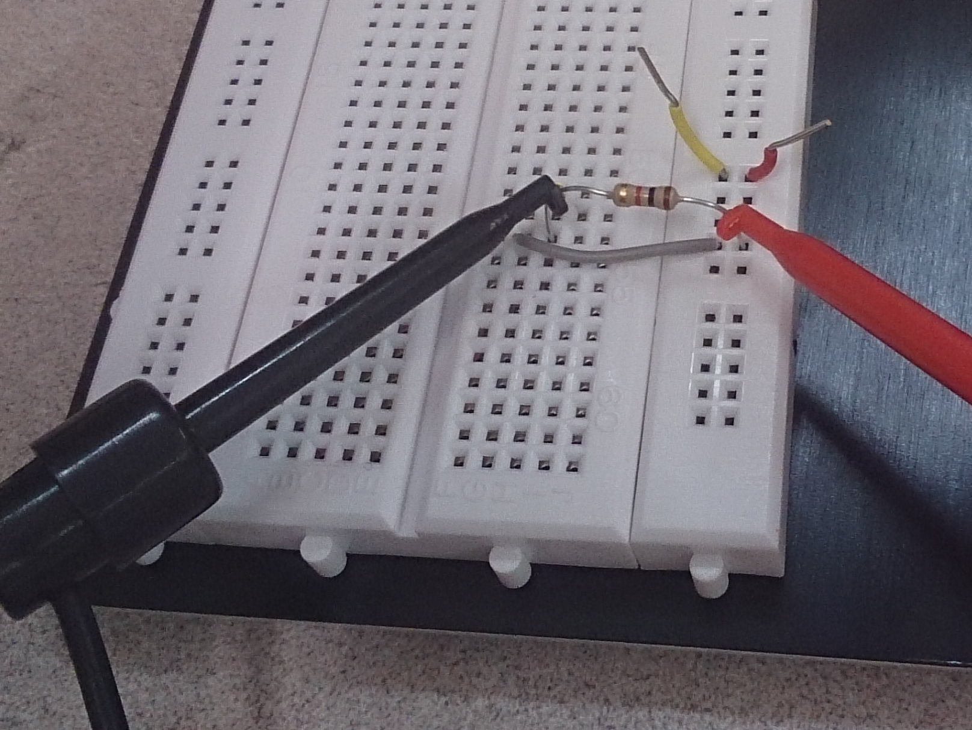

**Note:**

You can prepare the wire jumpers by cutting and stripping the insulation as show in Figure 4 - wire station (found in back of the electronics stockroom) and stripper tool:

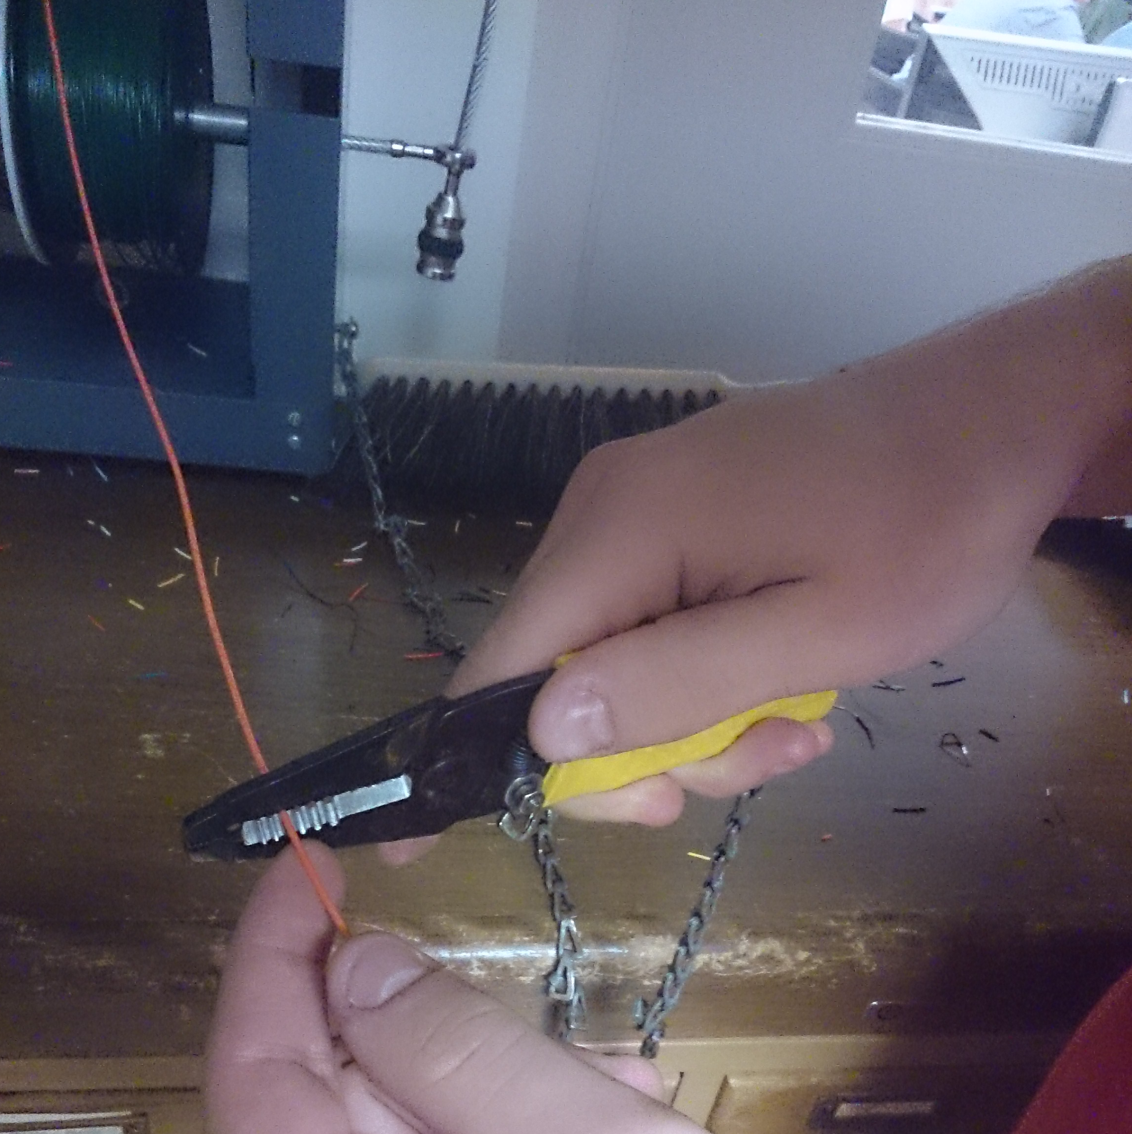

**Figure 4. Preparing Jumpers**

**Part II: Measuring Electrical quantities**

Identify and find the components of the circuit as shown in Figure 2. Wire the circuit using wires and the breadboard provided. Measure the resistance of R1 using the multimeter. Write your measurement in the lab notebook and in the matrix below

(Figure 5):

|  |  |  |  |
| --- | --- | --- | --- |
| **Nodes** | **Resistance** | **Nodes** | **Resistance** |
| Across Resistor | 0.98170K Ω | Breadboard GND to Resistor | .650 Ω |

**Figure 5. Resistance Measurements**

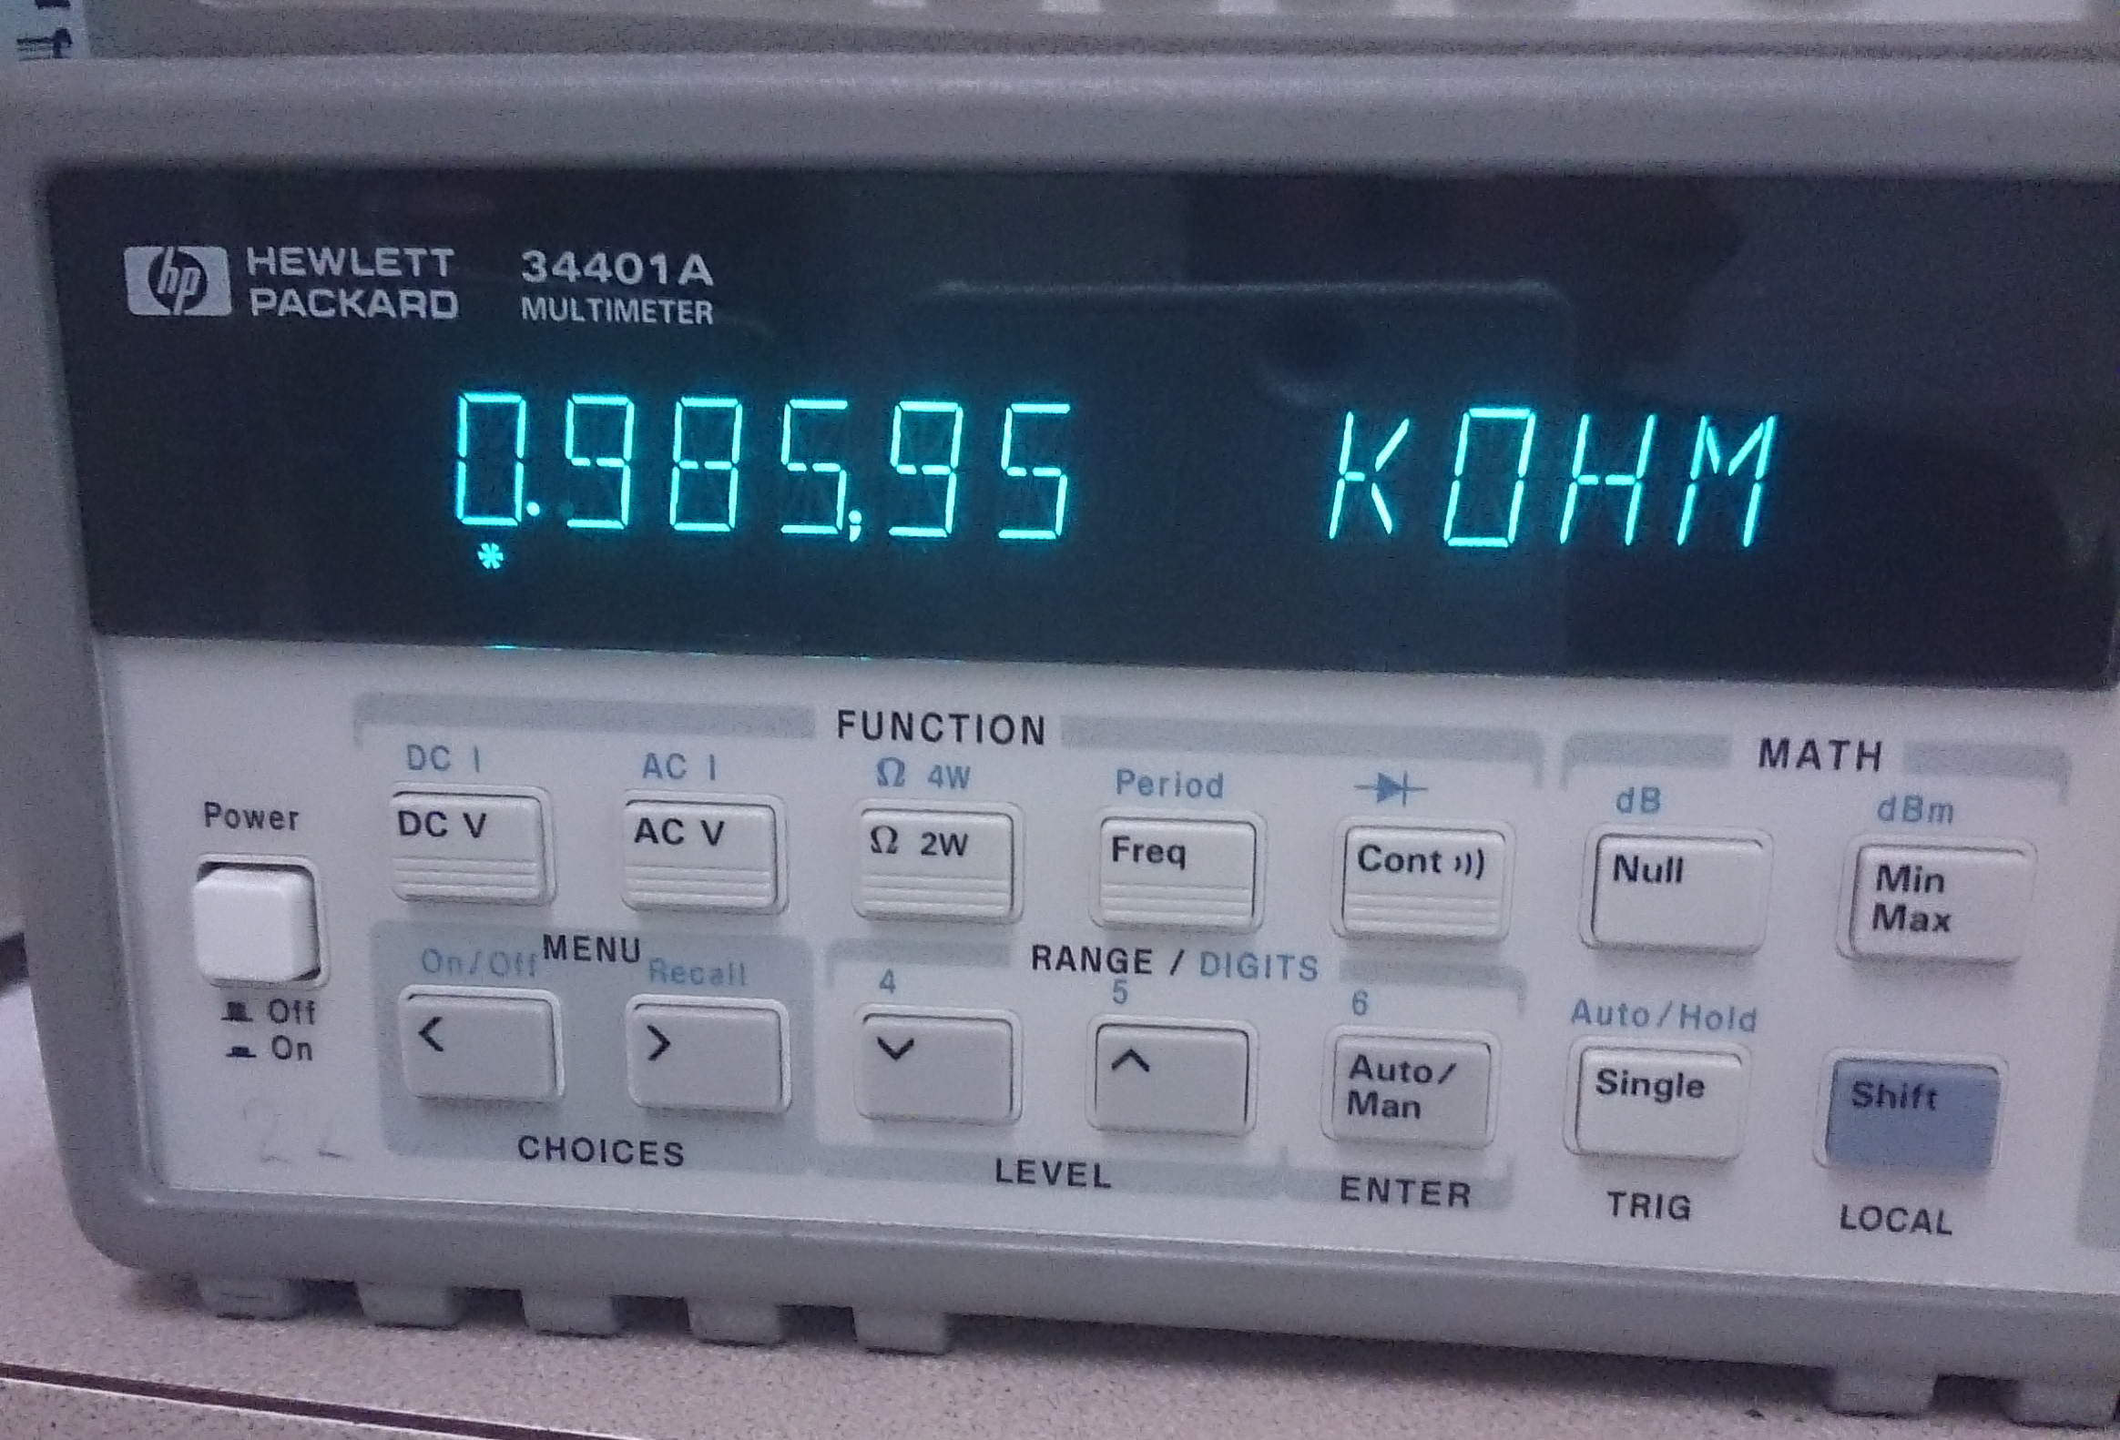

**Figure 6. Resistance Measurements**

Now Measure the voltage ACROSS R1 and ACROSS V1 (the power supply). Write your measurements below and in your Engineering Notebook(for Calculations):.

|  |  |  |  |
| --- | --- | --- | --- |
| **Nodes** | **Vres** | **Nodes** | **V** |
| Voltage Across R1 | 5.239V | Voltage Across V1 | 5.2415V |

**Figure 7. Voltage Measurements**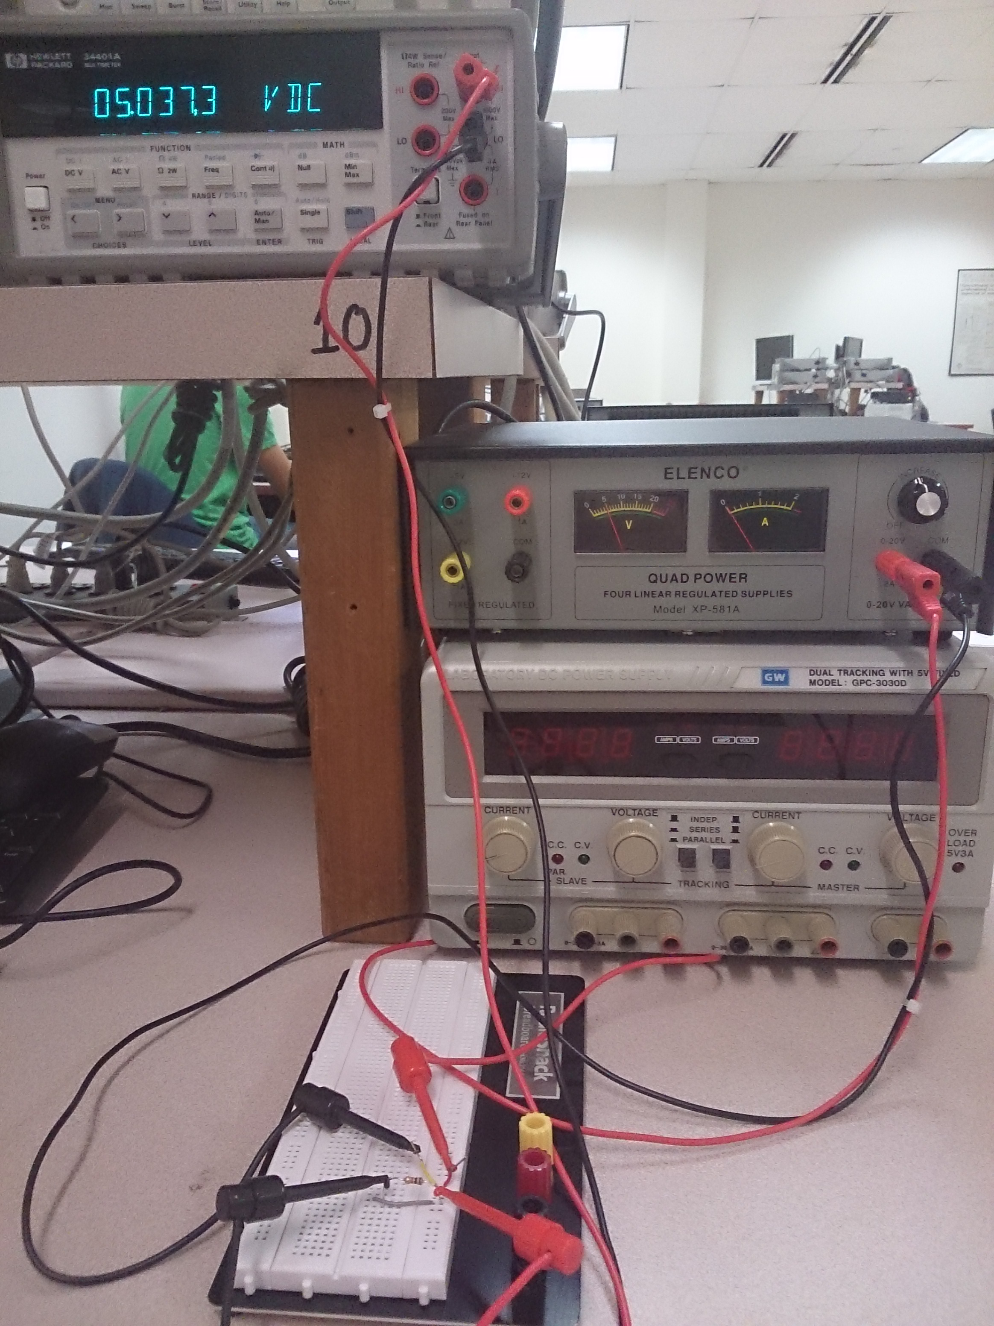

**Figure 8. Voltage Measurements with 5V Power Supply**

Measure the current (I) flowing THROUGH the circuit. Write your measurements below and in your Engineering notebook (for calculations).

|  |  |  |  |
| --- | --- | --- | --- |
| **Nodes** | **Ires** | **Nodes** | **Is** |
| Current through R1 | 5.197mA | Current Delivered by V1 | 5.195mA |

**Figure 9. Current Measurements**

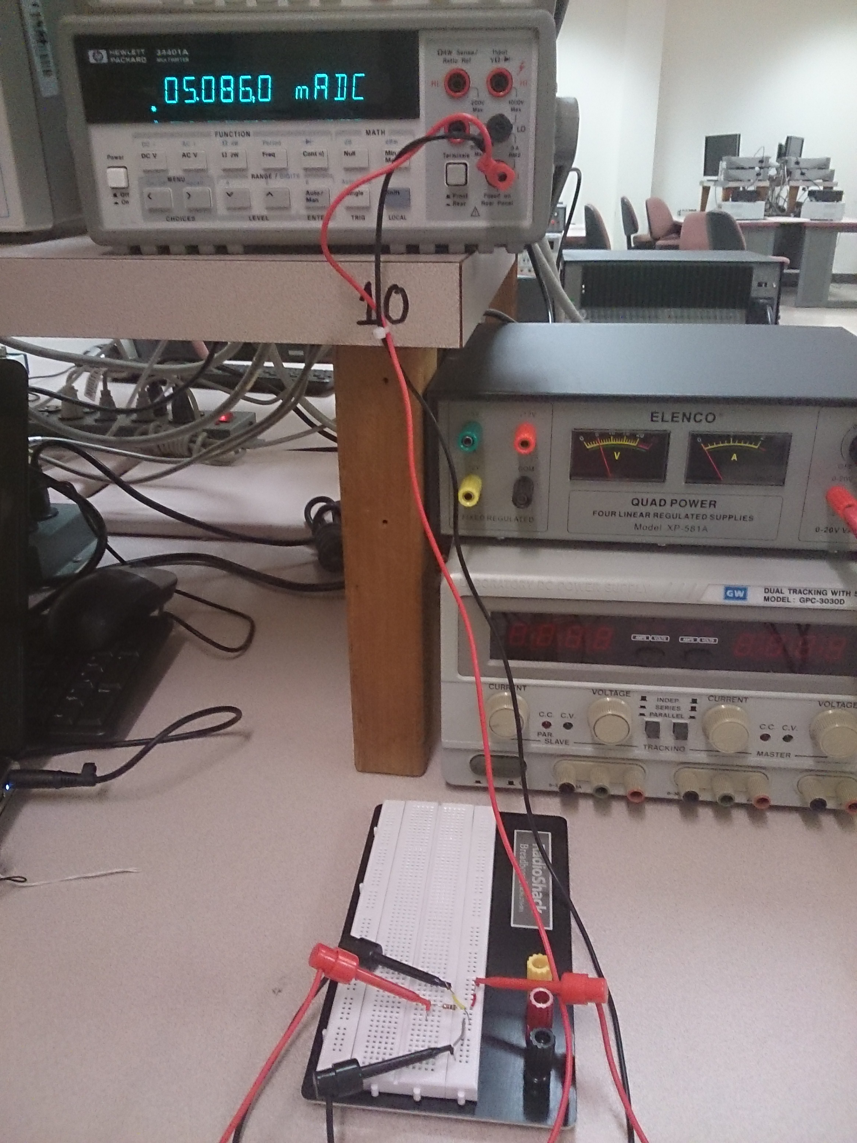

**Figure 10. Current Measurements,**

**NOTE THE CURRENT PATH AND METER TERMINATION CHANGES**

**Discuss and answer following questions in the lab report.**

* Describe how resistance, voltage, and current are measured in a circuit, use Ohms Law to describe this relationship:

Voltage is measured using a voltmeter which is an extremely high resistance instrument placed in parallel (in order to find the potential difference between two points) .Current is measured in amps with an practically zero resistance apparatus known as an ammeter that is placed in series with the part of a circuit it is measuring. Resistance is found using ohms law (V=IR) to derive resistance from voltage and current.

* Is the measured resistance of R1 within tolerance:, (Remember Gold = 5%, Silver = 10%)

R1=1-(.9817/1)*100=1.83% therefore the measure of resistance is well within a 5% tolerance .

* Is the measured value of the voltage across R1 (VR1) within 10% tolerance if the ideal value of VR1 is 5V?

1-(5.197/5 )*100= 3.94% tolerance (Yes it is within 10% tolerance)

* What relationship, if any, exists between the voltages V1 and VR1?

They should be exactly the same voltage because the breadboard circuit we constructed was in series where voltage is constant throughout.

* Explain any Problems and Learning’s you had during this lab and Your Solution(s)

The only problems we encountered were a general lack of knowledge in the subject area of circuits and measurement, once explained to us the lab went smoothly. We learned how to use a bread board, how to integrate ammeters and voltmeters into a circuit correctly as to achieve accurate measurements and prevent a short circuit. During the lab we identified and learned how to use many apparatus such as alligator/pinch clips ,resistors ,bread boards, wire cutters/strippers, power sources (grounding a circuit), voltmeter, ammeter and multimeter.

**\* Attach this handout at the end of your lab report.**

**Bryan Guner**

**Your Name: ____________________________________________________________**

**Part I: Breadboard Basics**

Lab Date: ________9/8/14___________ Check by: ________________________________

Lab Partner(s): **__Karly Hildin Haley Scott________________________________________________________**

**Part II: Measuring Electrical Quantities**

Lab Date: ____________9/29/14_______ Check by: ________________________________

Lab Partner(s): **___________________Same_______________________________________**

[1] Wikipedia, available at: <http://www.widipedia.org>

[2] The electronics club, available at: <http://www.kpsec.freeuk.com/breadb.htm>